ISM 4403 Homework Week 9

### Tasks:

Using Jupyter Notebooks perform the following tasks:

Part 1:

Create a variable “a” containing the number 3 **CHECK**

Create a variable “b” containing the number 5 **CHECK**

Add the two variables and store them in a variable named “c” **CHECK**

Create a print statement that will print the following 3 + 5 = 8, it should work with any value of a, b, and c. **CHECK**

**DONE**

Part 2:

Create a function named addTwoItems that takes two parameters firstNumber and secondNumber then performs the following: **CHECK**

Add the two variables and store them in a variable named “thirdNumber” **CHECK**

Create a print statement that will print the following 3 + 5 = 8. **CHECK**

Return the value of “thirdNumber” **CHECK**

Call your function passing a and b, storing the result in “c” **CHECK**

Print “c” **CHECK**

Part 3:

Create a function named createSomeString that takes two parameters firstNumber and secondNumber then performs the following.

Call addTwoItems passing firstNumber and secondNumber.

Store the result of the function in a variable named thirdNumber.

Create a string that will print the following when given the numbers in part 1. 3 + 5 = 8.

* NOTE: This should return the contents of firstNumber, secondNumber, and thirdNumber for any input.

Return the string **CHECK**

Part 4:

Create a loop which counts from 0 - 100 storing the current number 0 - 100 in a variable named “i”.

Please have the loop print every number divisible by 10 forming a comma delimited list.

Example: 0, 10, 20, 30, 40, 50, 60, 70, 80, 90

Please have the loop break out when the number store in i is 79, this should stop at 79 and your code should not print 80, and 90.

Part 5:

Create an if statement which prints: “Hello World” if the value stored in “c” is less than 5, the statement should print “Goodnight world” if the value is greater than or equal to 5.

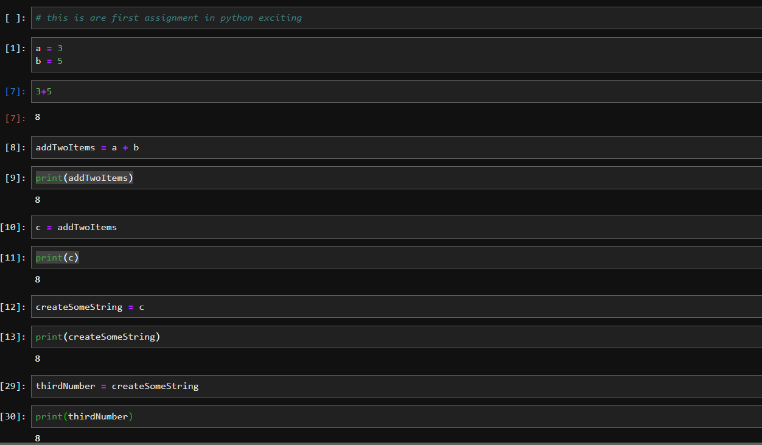

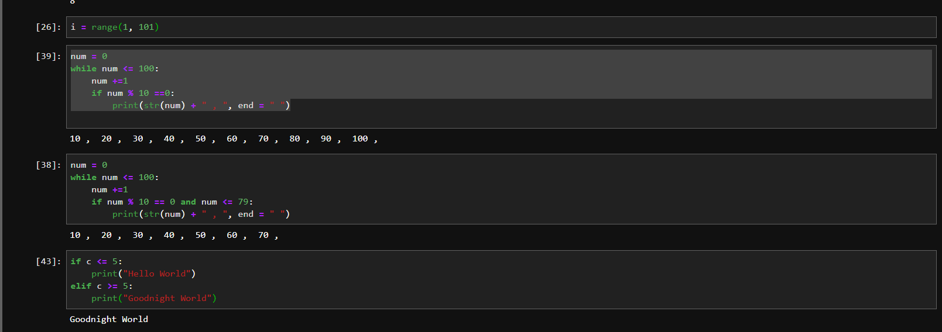

**Paste your code here**

**End of Paste**

**Paste your results here**

**End of Paste**

**Rubric:**

20% for answering each part correctly.